  - CROSS-CULTURAL COMMUNICATION
  - Learning material for the study module “Start-ups for sustainable environment created by youngsters”

Cross-Cultural Communication
  - Learning material for the study module “Start-ups for sustainable environment created by youngsters”

Current learning material is prepared for the teachers of high-school and gymnasium level students participating in Interreg Central Baltic project CB851 “ChangeMakers - Start-ups for sustainable environment created by youngsters” to introduce cross-cultural communication challenges, barriers, and skills. This knowledge will enhance students’ abilities in efficiently communicating with other people with different cultural backgrounds. Materials are compiled by the experts of Stockholm University and meant for two 45-minute sessions. Supplementary educational tools such as texts, PowerPoint presentations, video clips, role-play practices, online or offline games, exercises and assignments are also prepared to engage students in group activities. All materials are available at the Interreg Central Baltic ChangeMakers project’s e-learning platform: https://sub.samk.fi/changemakers-eplatform/

Stockholm University, 2021
TABLE OF CONTENT
Outline for SESSION 1 4
October 13, 2021 4
0 - Preparation 5
0 – Preparation 5
I – Telephone Charades Ice-Breaker Game 6
II – Cross-Cultural Communication 8
Slide 1 Title 8
Slide 2 What is cross-cultural communication? 8
Slide 3 What is culture? 9
Slide 4 Oberg’s Iceberg model 9
Slide 5 Stereotypes 10
Slide 6 Communication and conversational styles 11
Slide 7 Barriers to communication 12
Slide 9 Cross-cultural miscommunication 14
III – Group discussion 15
Slide 11 Group discussion 15
Outline for SESSION 2 16
November 17, 2021 16
0 - Preparation 17
I – Role play activity 18
II – Task and Discussion 20
References 21
Appendix 22
Cards for the role play activity in Session 2 23

Outline for SESSION 1

October 13, 2021
Table below summarizes the outline and estimated time for the cross-cultural communication lesson for session 1 on October 13th 2021. Topics and materials related to each chapter are presented in the following sections. Adaptions to the learning material are encouraged. Please inform the ChangeMakers team if you had to significantly alter the materials. That supports improvement of the original materials.

Order | Chapter | Estimated duration
0 | Preparation | Prior to class
I | Telephone Charades Ice-Breaker Game: Explaining to students what they need/going to do in this activity and letting them play | 15 min
II | Cross-Cultural Communication: Presenting the PowerPoint material related to cross-cultural communication, challenges, and skills, or showing the recorded lecture | 20 min
III | Discussion: Group discussion for students to reflect on the topics and the game activity | 10 min

0 - Preparation
1. You can use an online platform, such as Mentimeter or any other tool, to get all students feedback at the same time on a topic and conclude them together on the screen. Such tools can be used in slides 4 and 5, for instance, in the cross-cultural communication presentation.

0 – Preparation
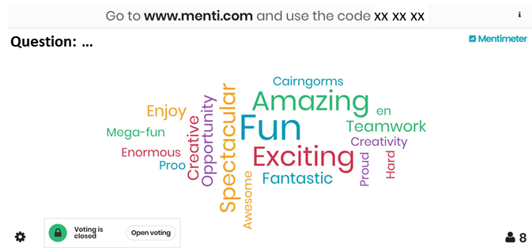
Figrue 1. Use an interactive platform such as Mentimeter and presenting the outcomes on the screen
2. Have a smart phone ready for the telephone game activity (in chapter III) to record and later screen in the class.
Figure 2. Using smart phone for recording students’ activities

I – Telephone Charades Ice-Breaker Game
Estimated duration ~15 minutes

Telephone Charades (also known as Charades Down the Line) is a hilarious icebreaker in which a person acts out a charade only for the next person in the line, who in turn acts out for the next person. The last person standing in line attempts to guess what the original message was. Teachers need to first explain to students that we are going to do a group fun activity based on some communication skills.
How to Play?
Choose 10-15 students (or ask for volunteers – the more students, the merrier) and ask them to line up in a row, facing the left side of the room. Ask the first person to turn around to see the message to be acted out (choose a sentence from the list that is included in the end of this chapter and write it on a piece of paper). Reveal the message to the first student and display the message to the audience as well. Keep it as a secret from other students standing in the line. The first person turns around and taps the next person in line on the shoulder. He/She then acts out the message using classic charades rules (no talking or noises permitted) and turns around. The second person then taps the third person and acts out his or her understanding of what was acted out. Then turns around. This process continues until the message reaches the last person in the line, who should guess what the action is. At the end, bring both the first and last students beside each other and ask them to act out again. Ask the last student to guess the message and compare it with the original message which was given to the first student.
The teacher (or another student out of the line) records the activity by a smart phone. The recorded video will be presented to all students on the class screen at the end of the session to make them think and reflect on what they have learnt. Where and why did the communication go wrong?
After the activity, teacher can talk about the difference(s) between performance of the first and the last students and have a short discussion in the class about the miscommunication that happened in the activity. It does not need to go too deep in the discussion, explanations and concepts! This can be kept for the end of the session when students have listened to the lecture and got more information on the concept of cross-cultural communication, barriers and skills.

Watch these videos to get a better idea of this activity:
https://www.youtube.com/watch?v=D-YHC8b6Hjk
https://www.youtube.com/watch?v=ilZuT7Gy0Qw

Hints:
- Have a group of students watch as the actions get more exaggerated throughout the line.
- No words! Only actions
- Each student can only act once while passing the message to the next one. The next student may ask for repeating the performance, but the request must be rejected. They should pass the message as they see it for the first time.
- The student who passes the action must then turn around and must not watch the next student performing.
- Make sure that students waiting in the line for their turn, do not turn back to see what is happening even if they hear loud laughs and noise from the crowd.
Sample messages:
- I rode the bike and fell.
- Riding a motorcycle
- Performing at a rock concert
- etc. (you can also suggest)

II – Cross-Cultural Communication
Estimated duration ~20 minutes
PowerPoint presentation: CB851_Cross-cultural communication.pptx
Recorded presentation: CB851_Cross-cultural communication.mp4

The chapter starts with PowerPoint presentation, introducing the concept of cross-cultural communication and the potential challenges of working in international teams. Here, materials included in the presentation are explained in the order of slides. There is also a recorded presentation that can be used for teachers’ preparation or be screened in the class.

Slide 1 Title
One of the project’s aims is to enable the students to experience teamwork across borders and to gain competence in cross-cultural communication. The following slides will present an introduction into the topic of communication across cultures including theoretical concepts on cultures and communication as well as the challenges of working in international and hence inter-cultural groups.

Slide 2 What is cross-cultural communication?
When people from different countries and cultures meet, they immediately start interacting and communicating. Cross-cultural communication is therefore “about the way people from different cultures communicate when they deal with each other […].” [1:2]
This can happen in different situations and forms and involves diverse forms of communication. The spoken language refers to verbal communication and is about the language people speak but also what they say and how they say it. Non-verbal communication means body language including mimics and gestures, for example when someone nods or shakes their head as a replacement for yes and no but it can also just be a facial expression as a reaction to something. Written language has become more and more important as digital communication has become more widespread. It also focuses on how language is phrased but lacks sub-contexts of spoken language such as the tone of the voice. The language of etiquette refers to conventions in communication, for example that people shake hands to greet – at least when there is no global pandemic.
Cross-cultural communication is therefore always present when people from different cultures communicate, whether that is face to face or located far away from each other. And no matter if they speak, just look at each other, write an email or just follow rules of politeness.

Slide 3 What is culture?
Before talking about potential definitions (before clicking in this slide), maybe the students themselves could be asked to give some ideas what they think culture is in a general perspective and how its meaning could be summarised. Maybe they also come up with different aspects of the term “culture” and thereby see that it has very diverse meanings.
A common definition of “culture” relates to the aspect that it is a “shared system of meanings [which] dictates what we pay attention to, how we act and what we value” [2:13]. Culture is therefore created and shaped by the people living in and with it and therefore differs between societies. It determines the way we see and perceive, assess and evaluate the world around us including ourselves and the actions of others. The culture we grew up in or that we learn to live in gives us glasses through which we then see the world. It therefore gives us the ability to understand the rules, values and customs of the society around us, but it also limits our perspective [1,3]. By meeting people from other cultures, we can then learn to make our glasses more colourful and gain understanding for other perspectives.

Slide 4 Oberg’s Iceberg model
Icebergs are a common visual metaphor for phenomena whose visible aspect is smaller than what stands behind it as most of an iceberg is hidden under water. What is seen from the outside is therefore much less compared to what’s going on underneath. This can be applied to the concept of “culture” dividing it into the visible and explicit parts of culture on one hand and the invisible and implicit aspects on the other hand [1].
Ask students if they can come up with any examples for these two forms of cultural aspects.
For this question, you can also use an interactive tool, such as mentimeter (https://www.mentimeter.com). If you sign up for free you get access to two question links. The students can then enter the links on their smartphone browsers and type in their answers to the question. These answers are then shown live on screen (anonymously) forming a word cloud. The answers which have been given more frequently will then become bigger. Alternatively, you can just discuss it verbally in class and ask the students to come up with some examples.
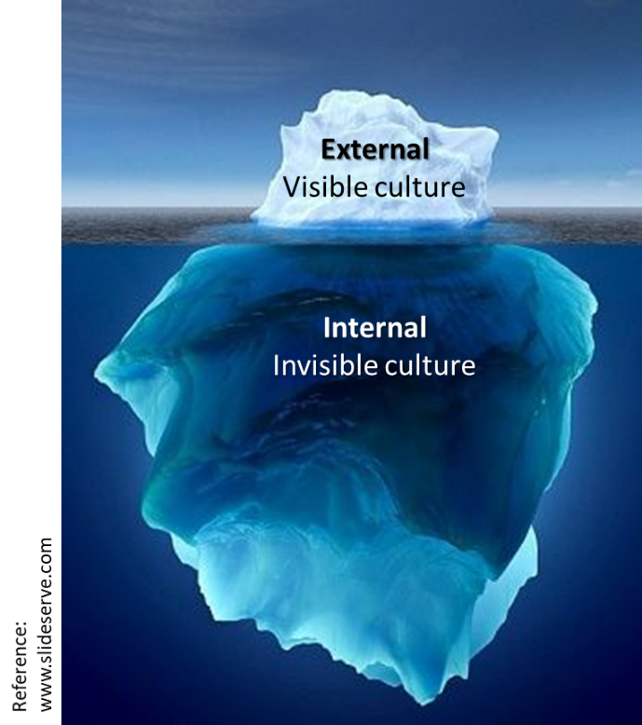
Figure 3. Schematic of Oberg’s Iceberg model
Some examples for these forms of culture can be:
- Visible/explicit culture: language, clothing, food, architecture, music, mimics and gestures (body language), etc.
- Invisible/implicit culture: values, assumptions, punctuality, status, risk taking, attitudes towards authorities, power distribution, etc.

Slide 5 Stereotypes
Stereotypes and prejudices are conceptions and beliefs about how people from other cultures and societies behave. Stereotypes determine what we expect or assume how somebody from another culture will act in a situation and thereby impact the way we behave towards them. By drawing assumptions about individual people we can easily misjudge and them. It is therefore very important to be aware of these stereotypes in our mind and how they change our behaviour. Although some stereotypes might be true to some extent, people from other cultures are always individuals and should not be judged based on stereotypes.
Ask students if they can think of some common stereotypes that other cultures have about their country.
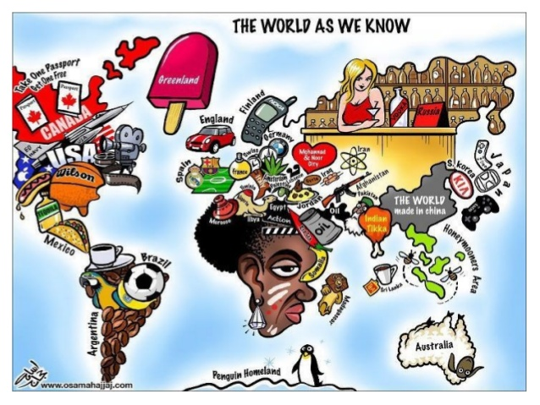
Figure 4. The world pictured based on stereotypes

Slide 6 Communication and conversational styles
When discussing the topic of cross-cultural communication, it is not enough to only think of how we act in our own culture and how we perceive others but also to consider the way we communicate. This is on one hand very individual and on other hand also influenced by our culture. In this regard, we can also differentiate between the style of communication and conversation.
Conversations can differ based on pacing, volume, level of participation, turn-taking, overlapping, and the frequency of topic changes. This depends of course on the situation and context of the conversation, considering for example a group discussion among friends or family, a personal talk with a very close friend or a work-related meeting. However, the mainstream conversation style is also part of our culture. Do we, for example, think it is impolite when someone interrupts us? Or do we wait for everyone to express their opinion on a topic before we change to another one?
Different styles of conversation are influenced by how the different members of the conversation communicate. This is very individual but also shaped by the culture we grew up in. Here you can see different ways of communication:
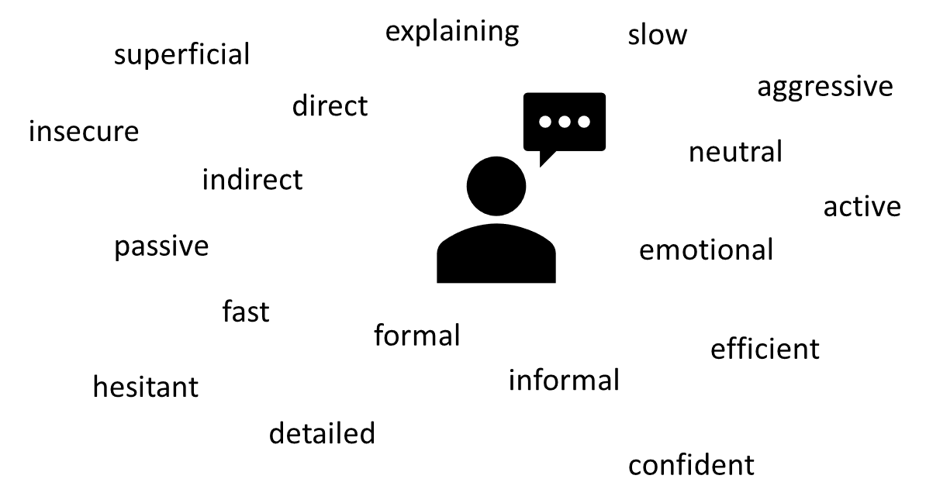
Figure 5. Communication styles and formats
Ask students what they think about the good communication styles for a team work and discuss for about 5 minutes.

Slide 7 Barriers to communication
Communication is not always easy and efficient as some barriers can occur to it.
Figure 6. Different perspectives on one object as a barrier for communication

Important communication barriers - Explanation
- Physical barriers: These are such things as inadequate equipment such as outdated computers, phones with poor signals, background noise, poor lighting, temperatures that are too high or too cold, tangible items that may interfere with communication efforts.
- Attitudes: Sometimes strong emotions like anger or sadness can impact your objectivity. Being extremely nervous, having a personal agenda, or asserting a need to win the argument, can make communications less effective. Such interfering emotions are also known as emotional noise.
- Language: This may seem like a minor obstacle, but even people who speak the same native language can have difficulty understanding each other, if they are from different generations or different regions of the same country. Slang, professional jargon, or regional colloquialisms, can hurt communicators with even the best intentions.
- Physiological barriers: ILL health, poor eyesight, hearing difficulties, and pain are all physiological obstacles to effective communications.
- Problems with structure design: Companies or institutions can have unclear organizational structures, making communication difficult. Bad information systems, lack of supervision, and insufficient employee training can also cause faulty communications.
- Cultural noise: People sometimes make assumptions about others based on their cultural background and associated stereotypes.
- Lack of common experience: It is a great idea to use examples or stories to explain or enhance a point. However, if others cannot relate to these examples because they do not have the same knowledge or shared experiences, then this tool will be ineffective.
- Ambiguity and overuse of abstractions: Using too many generalizations, proverbs, or sayings can lead to lack of clarity which in turn lends itself to misinterpretation.
- Information overload: It takes time to process large quantities of information. Too many details can overwhelm and distract the audience from important topics
- Jumping to conclusions: Making assumptions before listening to all the facts can be problematic in the least and catastrophic at worst.

Slide 9 Cross-cultural miscommunication
The consequences of cross-cultural miscommunication are misunderstandings leading to negative emotions such as feeling confused, embarrassed, angry, hurt, uncomfortable, unappreciated, rejected, etc. If we think back to the iceberg model of culture, cross-cultural miscommunication can be seen as crash of the iceberg parts which are located underwater. The implicit aspect of the different cultures clash which means the values, conceptions and thought patterns lead to differences in interpretation of the same situation. So cross-cultural miscommunication happens not because we might have a different style of clothing but rather because we think and interpret things differently.
Figure 7. Where miscommunication and challenges can happen.

III – Group discussion
Estimated duration ~10 minutes
PowerPoint presentation: CB851_Cross-cultural communication.pptx
Recorded presentation: CB851_Cross-cultural communication.mp4

Slide 11 Group discussion
Play and watch the recorded videos of the telephone charade game that students played in the beginning of the session as an inspiration for the group discussion around:
- When did communication go wrong in that activity?
- Why exactly does cross-cultural miscommunication happen?
- How can we prevent miscommunication?
Let the students form groups of 3-5 people and discuss these questions. They can write down their answers and ideas to these questions with examples and gather them together in the whole class afterwards.
These are some potential reasons the students could come up with:
Why does cross-cultural miscommunication happen?
- Assumption of similarities despite of differences
- Different styles of communication
- Different use of language
- Different interpretations of the same message due to different cultural assumptions
- Non-verbal misinterpretations
- Preconceptions and stereotypes
How can we improve cross-cultural communication and prevent misunderstandings?
- Listen
- Don’t assume
- Perceive and reflect
- Be understanding
- Ask, seek and give feedback

Outline for SESSION 2

November 17, 2021
The table below summarizes the outline and estimated time for the cross-cultural communication session 2 on November 17th, 2021. Topics and materials related to each chapter are presented in the following sections. Adaptions to the learning material are encouraged. Please inform the ChangeMakers team if you had to significantly alter the materials. That supports improvement of the original materials.

Order | Chapter | Estimated duration
0 | Preparation | Prior to class
I | Role Play Activity: Asking students to take the defined roles and play the activity | 30 min
III | Task: Discussing and drafting the “Principles of ChangeMakers Community” | 15 min

0 - Preparation
1. Print out the role cards for the role play activity as well as the follow up questions (Appendix).
2. Prepare red, blue and white color ribbons for the number of students in each group (Total number of students divided by three)
0 – Preparation
0 – Preparation

I – Role play activity
Estimated duration ~30 minutes

By assigning different roles to the students, they can change their perspective and experience a situation which might be uncommon for them. The role-play activity we suggest for the class is designed to enhance cross-cultural communication giving the students the opportunity to act and experience different cultures in their classroom.
Material: role card, ribbons of three different colours (red, blue, white)
Procedure:
- Explain that students will arrive from three different countries according to their roles to participate at a little party or gathering.
- All they have to do is get to know one another a little by talking briefly about the proposed topic to as many people as possible. Every round should be 3-5 minutes.
- Distribute role-cards (Appendix) and matching ribbons to all the students in class (The red, blue and white ribbons worn as ties or necklaces help students identify who is from which country during and after the game.)
- In the first round, the students should walk around and talk about what they do in their free time.
- In the second round, the students should talk about the last book they read, or film/TV show they watched.
- In the third round, students should talk about to which country they would travel to and why if they could choose freely.
- After the three rounds of walking around and talking about the different questions, they should be asked to sit down in groups of four or five, preferably so that there are people from Blueland, Whiteland and Redland in each group.
- Distribute the set of questions (Appendix) for the discussion and let them answer the questions and discuss the issues in their groups.

Tips:
Your students might not be used to role-play. Even if some students feel incapable of acting according to the roles allocated to them, the follow-up discussion might be entertaining and informative. In fact, this could provide another interesting issue for discussion: why is it so strange and difficult for us to avoid eye contact or pull earlobes when we talk to people? This can then lead to an awareness raising discussion on the different meanings of the same behaviour in different cultures.
This role-play also helps to recognise and observe features of other cultures. By playing set roles in unfamiliar social and cultural situations, students have a chance to experience different behaviours and recognise different values behind them. This is especially useful because as long as students are never exposed to foreign social customs and cultural values, they will not know how to react in intercultural settings. They may easily fabricate judgmental opinions about other people simply because they have never seen anything different from their own culture’s norms and standards.

II – Task and Discussion
Estimated duration ~15 minutes

Drafting the “Principles of ChangeMakers Community”
Now that the students have gotten familiar with the concepts, definitions, and challenges of cross-cultural communication, it is the time for suggesting some rules to follow in the teamwork activity for this project. These rules are meant to prevent cultural misunderstandings, avoid creation of unpleasant feelings, encourage team members to gain deeper understanding of each other, and ensure a safe and pleasant atmosphere for teamwork activities.
Please separate the students into smaller groups and let them discuss the questions and topics below. They can also share some previous experiences with each other.
- What are the rules that you want to be included in the teamwork at ChangeMakers?
- How shall group discussions in the team be held?
- What are some important values that you think must be respected in the team?
- What are cultural differences that might occur in your team?
- How can you avoid (cross-cultural) miscommunication in your team?

Once that all suggestions are collected from all the schools in different regions (Sweden, Finland, Latvia, Estonia, and Åland), they will be combined in a single document as:
“The Principles of ChangeMakers Community”

References
[1] Hurn, B. and Tomalin, B. 2013: Cross-cultural communication. Theory and practice. (Palgrave Macmillan).
[2] Trompenaars, F. 1993: Riding the Waves of Culture (London: Nicholas Brealey Publishing).
[3] Magala, S. 2005: Cross-cultural competence. (Routledge).
[4] https://www.youtube.com/watch?v=f5Tao6KHV5w
[5] https://www.youtube.com/watch?v=YMyofREc5Jk
[6] https://www.youtube.com/watch?v=D3a3fgUkw6c
[7] https://www.youtube.com/watch?v=D-YHC8b6Hjk
[8] https://www.youtube.com/watch?v=ilZuT7Gy0Qw

Appendix

Cards for the role play activity in Session 2

You come from Redland. You like to meet foreigners, but you really dislike being touched by strangers. In your country, you rarely look into each other’s eyes, and you always avoid eye contact when you first meet someone. You do not speak when you are not being asked. | You are from Blueland. In your country, people gently, but consistently touch each other’s arms when they talk. You always smile and agree, even though you actually do not. You like to meet foreigners, but you avoid people from Whiteland. | You come from Whiteland. You love to meet people and express your enthusiasm with a lot of gestures. When you meet someone, you touch your earlobes and bow a little to say “hello” politely. You like to interrupt people and tell them about your opinions, even though they have not asked you.

Follow-up questions for the role play activity in Session 2

- What did we learn about the three different cultures?
- What is the role of physical contact?
- What caused (or could have caused) conflicts?
- How did participants avoid/solve conflicts?
- Are there any similarities between your culture and any of these three cultures?
- What are some of the differences?
- Which culture did you find the strangest of all?
- What else would you like to learn about these cultures?
- How did you feel while you were participating in the game?
- What did you notice when you were observing the role-play?

The study material does not propose the possible breaks that might be needed to keep the focus and good pace. Teachers are expected to estimate the need for breaks based on school and group specific needs.
The study material does not propose the possible breaks that might be needed to keep the focus and good pace. Teachers are expected to estimate the need for breaks based on school and group specific needs.

