  - INNOVATION MANAGEMENT
  - Learning material for the study module “Start-ups for sustainable environment created by youngsters”

  - INNOVATION MANAGEMENT
  - Learning material for the study module “Start-ups for sustainable environment created by youngsters”

LECTURER MATERIAL
Current learning material is prepared for the teachers of high-school and gymnasium level students participating in Interreg Central Baltic project CB851 “ChangeMakers - Start-ups for sustainable environment created by youngsters” to better understand Innovation Management. Materials are compiled by the experts of Riga Technical University and meant for a 75-90-minute lesson and is supplemented with presentation, available at the Interreg Central Baltic ChangeMakers project’s web page https://sites.utu.fi/changemakers/

Riga Technical University, 2020

Author of the learning material:
PhD Elina Mikelsone

TABLE OF CONTENT
Proposed outline of the lesson 3
0 - PREPARATION 4
Homework prior to the lesson 4
I – INNOVATION MANAGEMENT 5
1.1. Definitions of Innovation 6
1.2. Preconditions of Innovation 8
1.3. Different Ways of Innovation Classification 10
Product, Process, Marketing, Organization Innovation 10
1.4. Innovation Process 11
1.5. Innovation management 12
III – AFTERPARTY 14
References 15

Proposed outline of the lesson
Table below proposes outline of the Innovation management lesson and the estimated duration of each sub-session. In the following chapters, you can find the topics we recommend you cover under each stage. Adaptions to the learning material are encouraged, please inform the CM team if you alter the materials, so we could consider the adaptions to be included for the course to be carried out in 2021.

Order | SUB-SESSIONS | Estimated duration
0 | Preparation: students to do some warmup tasks and gain intriguing innovation literature | Prior to class
I | Introduction: general discussion based on everyone’s personal experience and the homework students were invited to complete (see previous chapter) | 10 min
II | Innovation management session: presentation with practical tasks | 45 min
III | Afterparty: additional creative thinking method, idea evaluation and development method exploration that could help in innovation management | After the class

0 - PREPARATION
All students at the age of 15-18 are welcome to take part in the course. No previous experience is required. Only an open mind and curiosity to learn something new are needed to complete the proposed assignments.

Homework prior to the lesson
DO:
  - Exercise.1. In 2 minutes write down as many functionalities of pencil as possible (be creative)
EXPLORE ADDITIONAL LITERATURE SOURCES:
- Anthony, S.D., 2012, The little black book of innovation, Harvard Business review Press,Boston
- Berkun, S.,2001, The Myths of Innovation, O’Reilly, Sebastopol
- Gailly, B., 2018, Navigating Innovation, Springer
- Schaufeld, J., 2015, Commercializing Innovation, Springer
- Tidd, J., Bessant. J., Pavitt, K., 2001, Managing Innovation, 2nd edition, John Wiley&Sons

I – INNOVATION MANAGEMENT
Estimated duration of the session ~45 minutes
Slides: INNOVATION MANAGEMENT .pptx
Currently – at the age of information based economy the role of innovations becomes even more crucial.
The role of innovations has been widely discussed nowadays, because of the drawn conclusion, that it is the main precondition for the ability to maintain competitiveness of economy (Porter, 1985), (Christensen, et al., 2003), (Tidd et al., 2005) and business (O’Reilly, 2008), (Nooteboom, 1999). The main motivating factors for implementing innovations in a company are covered by Oslo Manual:
- Improvement of company operations;
- Improvement of productivity;
- Increase the ability to create innovations;
- Maintaining competitiveness and creation of competitive advantage (OECD, 2005).
As it seems innovations are a crucial element of our age, but what is innovations? There is a variety of definitions, but they all have common consensus on these elements:
- Innovation is the main force behind economic development and has existed since the dawn of the mankind;
- Innovation is the process and the effect of the process can be managed to influence its results;
- The result of the innovative process gives measurable benefits to the parties involved;
- Most well-known manifestation of innovations are the development of new products, manufacturing of product from new materials, development of new product design, method or strategy that is used to achieve better results;
- Invention is a part of innovation.

1.1. Definitions of Innovation
The term innovation has been defined in various ways and each definition encompasses a different aspect of the concept:
- An innovation is the implementation of a new or significantly improved product (good or service), or a process, a new marketing method, or a new organizational method in business practices, workplace, organization or external relations (OECD, 2005).
- The minimum requirement for an innovation is that the product, process, marketing method or organizational method must be new (or significantly improved) to the company. This includes products, processes and methods that companies are the first to develop and those that have been adopted from other companies or organizations (OECD, 2005).
- A common feature of an innovation is that it must have been implemented. A new or improved product is implemented when it is launched on the market. New processes, marketing methods or organizational methods are implemented when they are brought into actual use in the company operations (OECD, 2005).
- An innovation is defined as:
- The introduction of a new item that is one with which consumers are not familiar yet, or of a new quality of an existing item.
- The introduction of a new method of production, which needs by no means be founded upon a discovery of something scientifically new, and can also exist in a new way of handling a commodity commercially.
- The opening of a new market; that is the market into which a particular branch of manufacturer of the country in question has not previously entered, whether or not this market has existed before.
- The conquest of a new source of raw material supply or half-manufactured goods, again irrespective to whether this source has already existed or whether it has first been created.
- Carrying out of a new organization of any industry, like the creation of a monopoly position (for example through trustification) or breaking up of a monopoly position (Schumpeter, 1934).
- In an essential sense, innovation concerns the search for, and the discovery, experimentation, development, imitation, and adoption of new products, new production processes and new organizational set-ups (Dosi, 1988).
To better understand what innovation is and what it is not, The Oslo Manual points out changes in company, which are not innovations:
- Trading of new or improved products by wholesalers, retailers, warehouses and transport companies are not considered innovations;
- Purchasing or minimal upgrading of hardware that is identical to already installed one or extension or modernization is not innovation. New hardware or upgrade must be new in the company un must contain significant technical improvements;
- Firms engaged in product production and make single and often complex items according to customers’ orders. Unless the one-off item displays significantly different attributes from products that the firm has previously made, it is not a product innovation.
- Changes in the price of the product or the productivity of the process as a result of change in factual prices;
- If a company suspends some activities aimed at improving its efficiency, it is not an innovation;
- In certain industries such as clothing and footwear there are seasonal changes in the type of goods or services provided which may be accompanied by changes in the appearance of the products concerned. These types of routine changes in design are generally neither product nor marketing innovations. For example, the introduction of new season anoraks by a clothing manufacturer is not a product innovation unless the anoraks have, for example, a lining with significantly improved characteristics. However, if the occasion of seasonal changes is used for a fundamental change in product design, that is a part of a new marketing approach used for the first time by the firm, this should be considered a marketing innovation (OECD, 2005).
INNOVATION = NEW IDEA + VALUE + IMPLEMENTATION

1.2. Preconditions of Innovation
Some researchers write about the preconditions of innovation, for example, Skarzynski and his partners have identified 3 crucial preconditions – time and space, diverse thinking, combinational chemistry (see figure No 1.1.)
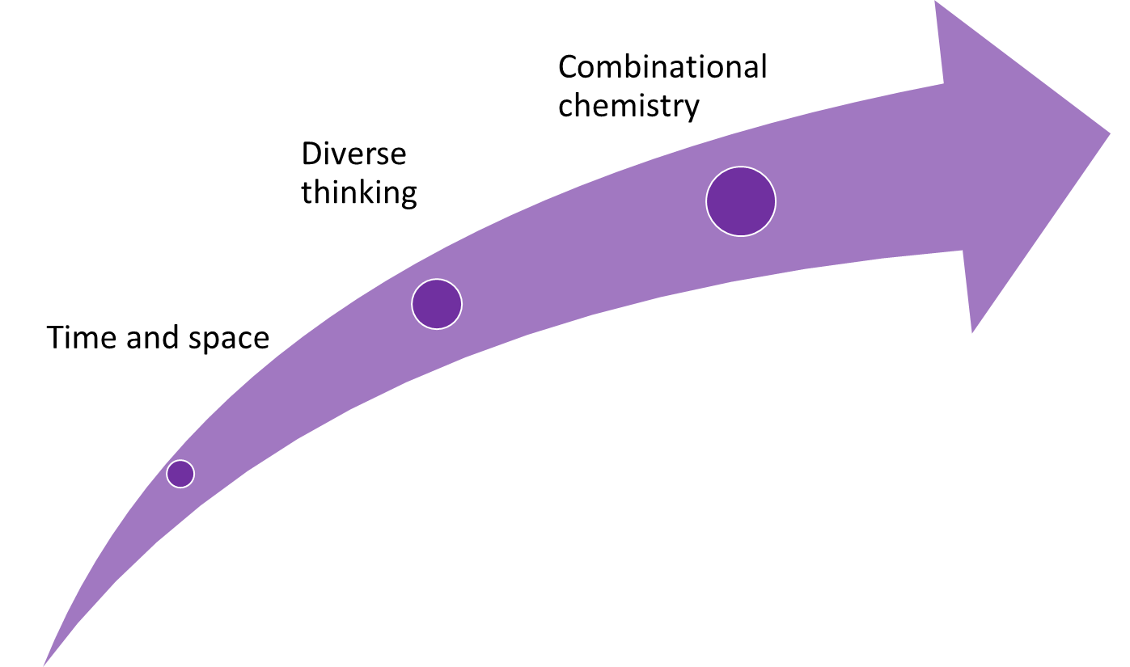
Figure no. 1.1. Preconditions of innovation
Source: Skarzynski et al. (2008)
Innovations have to have a defined time and space where people can operate within the process of innovation – that is to generate ideas and experiment. Google has 70/20/10 law, which allows employees to use 10% of work time for their projects, 20% for strategic goals and 70% for their direct work. Such companies as 3M and Gore have followed the example of Google by giving their employees respectively 15% and 10% of their time for innovations.
Diverse thinking is also crucial for innovations. To create such a thinking company one needs:
- Analytical and creative thinking;
- People from different levels in the organization;
- People with and without experience;
- People of different ages;
- People who master technologies and people who master people’s psychology;
- People from within and outside company.
The third precondition is to make the combinational chemistry, by making the structure of the company open to such initiatives, provide free flow of ideas etc.

1.3. Different Ways of Innovation Classification
Innovation can be classified by its results, pace of implementation, significance, process of cooperation etc. Each of the innovations can be classified in many different ways, for example, iPhone 6could be considered as a technological innovation as well as product innovation or gradual innovation, etc.

Product, Process, Marketing, Organization Innovation
A product innovation is the introduction of goods or services which are new or significantly improved with respect to their characteristics or intended uses. This includes significant improvements in technical specifications, components and materials, incorporated software, user friendliness or other functional characteristics. Examples – e-book readers, walkmans or GPS. Improved product innovations are a new model of Gillette razors or a new smartphone model.
A process innovation is the implementation of a new or significantly improved production or delivery method. This includes significant changes in techniques, equipment and/or software. Examples - implementation of barcodes or new machinery in the process of manufacturing, use of computers in product design, new methods of supply etc.
A marketing innovation is the implementation of a new marketing method involving significant changes in product design or packaging, product placement, product promotion or pricing. Examples –mineral water producer Zaķumuiža fills its water in bottles as well as different types of plastic containers like small yogurt cups. As a marketing innovation, an unusual advertisement in social networks or new methods of funding using Kikstarter may be considered etc.
An organization innovation is the implementation of a new organizational method in the company business practices, workplace organization or external relations. Examples – remote work opportunities or non-hierarchical organization of company or self-organization, like transport sharing network Uber.

1.4. Innovation Process
There are many views of how to define the innovation process, but one of the well-known conceptions is a theory of author A.T. Kearny - that innovation process consists of three parts- idea management, development processes and launch/ continuous improvements (IMP³prove, 2014), see figure 1.2.
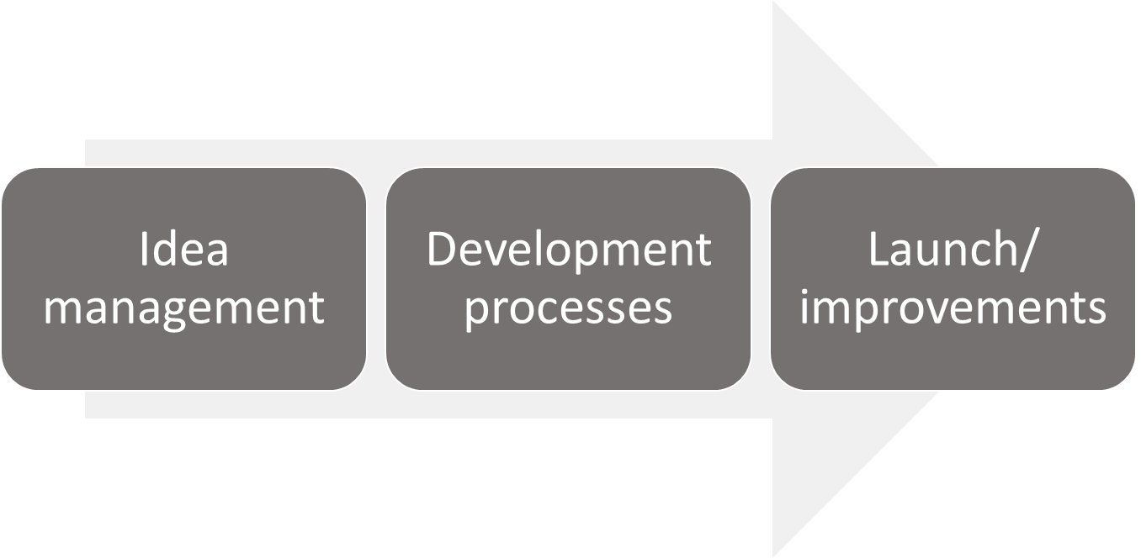
Figure no. 1.2. Innovation process
Source: developed on the basis of IMP³prove (2014)
The first part of innovation process is idea management. It consists of two parts- idea generation and idea development. Usually the first part is used to find a solution to a defined problem. Ideas could be created by a closed group, or the process of creation could involve many parties, such as customers, partners, suppliers, etc. Ideas could be created after a competitor or partner analysis. This process involves also idea management - idea evaluation and project/business plan development.
The second part of the innovation process is development processes, which includes research, development and deployment. The second phase may include a variety of activities:
• Research and scientific basis.
•Invention and intellectual protection.
•Prototype, pilot development, testing and improvement.
•Implementation planning.
•The required purchase of technology or the improvement.
•The launch.
The third phase is the launch/continuous improvements. At this stage the most important activities are innovation marketing, controlling, monitoring.
Innovation process in organization can be managed by a particular manager (the enterprise, innovation or project manager), which carries out the process of innovation management in collaboration with stakeholders. But it is possible that each stage of the innovation process has its own responsible person.

1.5. Innovation management
Innovation management’s goal is to successfully implement the innovation. On the base of it there is an innovation process, but the innovation ​​management is a complex system, which includes other components essential for innovation management. “A.T. Kearney House of Innovation” reflects a complex nature of innovation management, see figure 1.3.
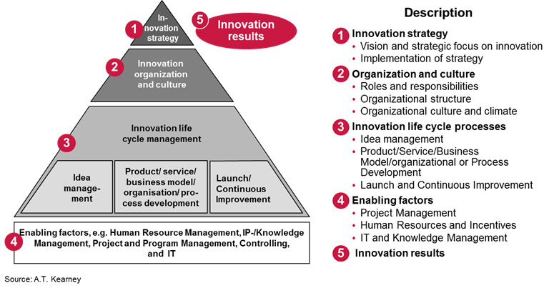
Figure no. 2.3. “A.T. Kearney House of Innovation”
Source: A.T. Kearney (2013)
‘’A.T. Kearney House of Innovation” concept covers all innovation management elements- from innovation strategy, innovation organization and culture to the innovation process (innovation life cycle management) and the enabling factors of innovation management (human resource management, IP-/knowledge management, project and program management, controlling, IT management), innovation results.

III – AFTERPARTY
Afterparty: additional creative thinking method, idea evaluation and development method exploration.

SOURCES FOR EXPLORATION

- www.creatingminds.org
- www.mindtools.com
- www.edwdebono.com
- www.thinkingschool.co.uk/resources/thinkers-toolbox /
- www.mindwerx.com
- www.fivewhys.files.wordpress.com

References
1. A.T. Kearny (2013), “Innovation”, available at: http://www.atkearney.com Date Accessed: 13.08.2020.
2. ATKearney, (2013), “Turbocharging Open Innovation in a 100-Day Blitz”, available at: http://www.atkearney.com/web/women-s-forum/detail/-/asset_publisher/VMEx2L1PhjPS/content/turbocharging-open-innovation-in-a-100-day-blitz/10192 Date Accessed: 13.08.2020.
3. Chesbrough, H.W., (2003), Open innovation: the new imperative for creating and profiting from technology, Harvard Business Scholl Publishing Corporation, USA, p.26
4. Chirstensen, C.M., Raynor M.E., (2003), The innovators solution: creating and suitaining successful growth, Harvard business school press
5. Dosi, G., (1988) ‘’The nature of the innovative process” in Dosi,G, Freeman,C et al (eds.) (1988): Technical Change and Economic Theory, Pinter Publishers, London
6. Drucker, P.F., (1993), Innovation and Enetrpreneuership, Harper&Row Publishers, USA
7. Eager, R., Van Oene, F., Ross, D., Dekeyser, C., (2011), “The future of Innovation Management: next 10 years”, available at: http://www.adlittle.com/prism-articles.html?&view=379 Date Accessed: 13.08.2020.
8. EARTO, (2002), “Europe Needs More Applied R&D”, available at: www.earto.eu%2Ffileadmin%2Fcontent%2F03_Publications%2F2002_03___01_Europe_Needs_more_applied_R_D.doc&ei=Ix8YVL6sCsTMyAOy74Io&usg=AFQjCNF30Zzp0muAEhPINLx5GegtfKfjaQ&sig2=8BDmsYGCXw3lNc0D_awFLA Date Accessed: 13.08.2020.
9. EC, (2004), Innovation Management and the Knowledge- Driven Economy, Luxembourg, Brussels, p.156
10. Garcia, R., Calatone, R., (2002), ‘’A critical look at technological innovation typology and innovative terminology: a literature review’’, Journal of product innovation management, Vol.19, pp.110-132
11. Gilliard, M., (2014),”Innovation sources” , available at: http://www.innovation-creativity.com/innovation-sources.html (accessed 16 September 2014)
12. Godin, B., (2008), Innovation: the History of Category, Working Paper No.1, Project on the Intellectual History of Innovation, INRS, Montreal, 62 p
13. Greely, H., Sahakian, B., Harris, J., Kessler, R.C., Gazzaniga, M., Campbell, P., Fara,h M.J., (2008), ‘’Towards responsible use of cognitive-enhancing drugs by the healthy’’, Nature, Vol.456, pp.702-705
14. Hepburn, N. (2013), “What is the culture of innovation?”, available at: http://www.marsdd.com/news-and-insights/what-is-a-culture-of-innovation/ Date Accessed: 13.08.2020.
15. IMP3prove, (2014), „IMP³rove Approach”, available at: https://www.improve-innovation.eu/sme/imp%C2%B3rove-approach Date Accessed: 13.08.2020.
16. Kim, E.C., Mauborgne, R., (2005), Blue Ocean Strategy: How to Create Uncontested Market Space and make Competion Irrelevant, Harvard Business Press
17. Latvijas Tehnoloģiskai centrs, (2009), ‘’IMPROVE: uz interneta bāzes veidota uzņēmumu pašnovērtēšanas sistēma inovatīvo procesu vadībai’’, available at: www.een.lv/system/.../IMPROVE_brosura_2010.pdf Date Accessed: 13.08.2020.
18. LTC, (2007), Innovative companies in Latvia 2007, Riga, Latvia, p.5
19. Moore, G.A., (2005), Dealing with Darwin: How Great Companies Innovate at Every Phase of their evolution, Penguin Group, New York
20. Mothe, C., Thi Nguyen, U.T, (2010), ‘’The link between non- technological innovations and technical innovations’’’, European Journal of Innovation Management, Vol.13, No.3, p.313.
21. Nacionālā inovāciju programma 2003.-2006.gadam, (2003), available at: http://polsis.mk.gov.lv/view.do?id=727 Date Accessed: 13.08.2020.
22. Nooteboom, B., (1999), Innovation, learning and industrial organization, Cambridge journal of economics, Vol.23, pp. 127-150
23. O’Reilly, C.A., Tushman, M.L., (2008), Ambididexterity as a dynamic capability: resolving the innovator’s dilemma, Research in organizational behavior, Vol.28, pp.185-206
24. OECD, (2002), “Frascati Manual”, available at: http://www.oecd-ilibrary.org/science-and-technology/frascati-manual-2002_9789264199040-en Date Accessed: 13.08.2020.
25. OECD, (2005), ‘’Oslo Manual: Third edition’’, available at:http://epp.eurostat.ec.europa.eu/cache/ITY_PUBLIC/OSLO/EN/OSLO-EN.PDF Date Accessed: 13.08.2020.
26. Porter, M.E., (1985), Competitive Advatage: Creating and Sustaining Superior Performance, Free Press, New York
27. Reader, S.M., Laland, K.N., (2003). Animal Innovation, Oxford University Press, Oxford
28. Schmidt, T., Rammer, C., (2007), ‘’Non-technological and technological innovations: strange bedfellows’’, pieejams: ftp://ftp.zew.de/pub/zew-docs/dp/dp07052.pdf (skatīts 2014.gada 16.septembrī)
29. Schumpeter, J.A., (1934), ‘’The theory of economic development: an inquiry into profits capital, credit, interest and the business cycle’’, Harvard Economic Studies, Vol.46, Harvard College, Cambridge, MA
30. Skarzynski, P., Gibson, R. ,(2008), Innovation to the Core: A Blueprint for Transforming the Way Your Company Innovates, Harvard Business Review Press
31. Tidd, J., Bessant, J., Pavitt, K., (2005), Managing innovation: integrating technological, market and organizational change, John Wiley & Sons, Sussex
32. Tidd, J., Bessant. J., Pavitt, K., (2001), Managing Innovation, 2nd edition, John Wiley&Sons, p.314-342

Additional sources:
www.creatingminds.org
www.mindtools.com
www.edwdebono.com
www.thinkingschool.co.uk/resources/thinkers-toolbox /
www.mindwerx.com
www.fivewhys.files.wordpress.com

The study material does not propose the possible breaks that might be needed to keep the focus and good pace. Teachers are expected to estimate the need for breaks based on school and group specific needs.

