  - PITCHING

  - Learning material for the study module “Start-ups for sustainable environment created by youngsters”

PITCHING
  - Learning material for the study module “Start-ups for sustainable environment created by youngsters”

Current learning material is prepared for the teachers of upper secondary and vocational education students participating in Interreg Central Baltic project CB851 “ChangeMakers - Start-ups for sustainable environment created by youngsters”. Materials are compiled by the experts of Åland´s Vocational School meant for two 45-minute session. Supplementary educational tools such as texts, PowerPoint presentations, video clips, exercises and assignments are also prepared to support this material. All materials are available at the Interreg Central Baltic ChangeMakers project’s e-learning platform: https://sub.samk.fi/changemakers-eplatform/

Author
Jaana Salminen
Teacher in Economics and Business
Åland´s Vocational School

Contents
Outline for SESSION 5
0 – Preparation 6
PREPARATION 6
I-PITCHING 7
Defining a pitch 7
Slide 2 – What is a pitch? 7
Slide 3 – Pitches 7
Slide 4 – Short pitches-elevator pitch 8
Slide 5 – Task 1-Fill in the greens 8
Slide 6 – Task 2-Fill in the added greens 8
II - THE STRUCTURE OF A WELL PREPARED PITCH 9
Slide 7 – 8 -- Let´s get inspired! 9
Slide 9 – The structure of a pitch deck 9
Slide 10 Intro part two 10
Slide 11 – The structure of a pitch deck 10
Slide 12 – Introduction 11
Slide 13 – Problem 11
Slide 14 – Solution 12
Slide 15 – Business model 12
Slide 16 – Validation 13
Slide 17 – Competitors 13
Slide 18 – The team 13
Slide 19 – The request 14
Slide 20 – Conclusion 14
Slide 21 – Final tip 15
III – STUDENT TASK 15
Slide 22 – Task – create a 3 min pitch 15
Slide 23 – The purpose and goal of a pitch deck 15
Slide 24 – What can go wrong ? 16
References 16
APPENDIX I 18
Pitch glossary 19
APPENDIX II 22
Task for student teams is: 23

Outline for SESSIONS
9.3. & 23.3.2022
Table below summarizes the outline and estimated time for the pitching lesson on 9.3. and 23.3. Topics and materials related to each chapter are presented in the following sections. Adaptations to the learning material are encouraged. Please inform the ChangeMakers team, if you had to significantly alter the materials. That supports improvement of the original materials.

This project’s “ChangeMakers – Start-ups for sustainable environment created by youngsters” lesson is supposed to give an overview on the most important aspects of pitching, what it means to give a pitch and what are the preparations and things to consider when giving out a pitch of your product/solution.

ORDER | CHAPTER | ESTIMATED DURATION 1
0 | Preparation  Discuss pitching with your students and watch an introductory video | 10 min
I | Pitching  What is a pitch – types of pitches  Student task 1  Student task 2 | 20 min
II | The structure of a well-prepared pitch (1) | 15 min
 |  | Part one 45 min
II | The structure of a well-prepared pitch (2) | 15 min
III | Student task 3 | 30 min
 |  | Part two 45 min
 |  | Total 90 min

PREPARATION

0 – Preparation

In the beginning of the lesson take the time to discuss with your students if they have ever heard an entrepreneur present a pitch and watch a funny introduction video with your students, where Rene Gracie from the company Quickflip presents his idea and company in the Shark Tank-television program. https://www.youtube.com/watch?v=QLUyzXhoBik
Also take the time to discuss with your students that the teams will present their pitch (video) at the Challenges to Business-event 20.-23.4.2022 (internationally online and onsite locally)

I-PITCHING

The aim of this lesson is to introduce the concept of a pitch and what are the most important qualities to consider when presenting your business. The first part of the lesson focuses on defining the pitch and presents different length pitches. The second part introduces the structure of a well-structured pitch and the necessary steps to be taken, in order to create one. The third part of the lesson introduces the student task and also the possible problems that might occur.

Defining a pitch

Slide 2 – What is a pitch?
First it is important to define a pitch. A pitch can be defined as a sales presentation, a company presentation or an elevator pitch. As many other things, a pitch can have multiple different names, but they all have the same purpose. The main purpose of a pitch is to attract the audience and get them to do something (e.g. to invest in a company). A pitch can also be described: “as a speech that attempts to persuade someone to take action”.

Slide 3 – Pitches
There are different lengths of sales presentations (pitches). The pitch can be as short as a 30 second pitch, a 60 second pitch and as long as 3 minute or 5 minute pitch. A short pitch should give the audience the feeling that he or she would like to know and hear more about the topic. A longer pitch (company presentation) presents the most important things and aspects of the company in a clear and interesting way. A quote from Jon Callaghan, TrueVentures “ The best sales presentations make me feel like the train is leaving the station soon and it´s not waiting for me, so I need to hop on board quickly”. Take the time to discuss the metaphor with your students. What does that mean and how could it be achieved in a pitch?

Slide 4 – Short pitches-elevator pitch

This slide will describe the term elevator pitch. Imagine yourself in an elevator with the person that you are pitching to. You have time to present your pitch or your company´s main characteristics to him/her from the time the elevator leaves the ground floor until the moment that you reach the top floor.
Short pitches (30-60 sec.) briefly present the most important things about your business idea. The elevator pitch should arouse interest among your audience. The elevator pitch aims to arouse discussion after the presentation and call to action at the end, i.e. what are the next steps to move forward.

Slide 5 – Task 1-Fill in the greens

Let´s start by practising. You can ask your students to take the time and write their own pitch by writing the template in their notebooks and filling in the greens with their own information.
“Hello, we are [your name]!
The problem we want to solve is [the problem].
Our solution is [the solution].
Our most important customers are [the target group].
Our solution is unique because [value promise].
Let´s talk more!

Slide 6 – Task 2-Fill in the added greens

Ask the students to again add the texts in their notebook and after doing so they will have their 40 second pitch ready.
People who [description of the customer] and who have this [need / problem] are our customers.
Our [product / service] offers a solution to the problem and the benefits are [the most important benefits].
Unlike our competitors [mention a competitor] is our solution [your competitive advantage].
The next slides will introduce the guidelines in order to prepare a longer, 3 minute pitch.

II - THE STRUCTURE OF A WELL PREPARED PITCH

Slide 7 – 8 -- Let´s get inspired!

Firstly, let´s get inspired!

Slide 9 – The structure of a pitch deck

This slide will describe the structure of a pitch deck. The eleven points that a pitch deck has are:
- Introduction
- The problem and current solutions
- Solution and value promise
- Validation
- Market
- Business model
- Team
- Economic figures
- Competitor analysis
- Future
- Request

THE LESSONS ARE PLANNED WITH A BREAK AFTER SLIDE 9. PART TWO BEGINS WITH THE SAME SLIDE (9) THAT ENDS PART ONE.

Slide 10 Intro part two

Slide 11 – The structure of a pitch deck

This slide will describe the structure of a pitch deck. The eleven points that a pitch deck has are:
- Introduction
- The problem and current solutions
- Solution and value promise
- Validation
- Market
- Business model
- Team
- Economic figures
- Competitor analysis
- Future
- Request

Slide 12 – Introduction

The most important step is the introduction, as you can only give a first impression once, so be sure to start effectively! The introduction should cover who you are and what is the company that you’re representing.
What is your company’s tagline or slogan? Additionally you should summarize in a sentence the value that the company produces. Be sure to also remember that your company competes with the audience´s attention with, among other things, mobile phones and social media. One last thing to remember about introduction is not to spend unnecessary time on it.

Slide 13 – Problem

What is the problem (challenge) that your student start-up is solving? If you do not have problem, one could say that you do not have a business. Describe in one or two words sentences what the problem is and why it should be solved and more importantly, why the problem is worth solving.

Slide 14 – Solution

In the solutions phase of your pitch you should describe how your student start-up is solving the problem (challenge) and what is the solution that you have come up with? What is the product and or service that you are offering? What does your customer benefit from your solution? Present briefly how the solution is implemented and what makes it unique? Be sure to not to make the mistake of starting to present the product in detail.

Slide 15 – Business model
In this phase of your pitch it is time to present to your audience your business model and how your company makes money. Important questions to ask yourselves are: Who are the customers of your company? How are the customers reached, i.e. what are your sales and marketing channels? How is the product priced and how big is he market that the company operates in? NP! The customer is the one who pays for the product/service, the user can be different (e.g. a toy company´s user is a child).

Slide 16 – Validation

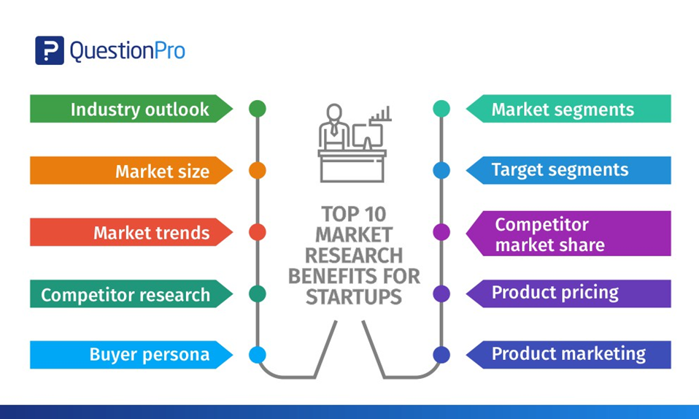
In this part of the student start-up´s pitch the aim is to tell the audience how the problem (challenge) has been investigated. Has the market size and customer´s needs and problems been investigated? The student teams should tell how the validation has been done: have they used interviews, surveys, studies or something else?

Slide 17 – Competitors

It is important to recognize what the competitors for each student start-up are. The questions to answer are: Who are the company´s most important direct competitors? How does the company differ from these competitors? Be honest and do not devalue the competitors.

Slide 18 – The team

While introducing the team behind the start-up the student teams should describe the competence of the team. What special knowledge does the team have that can create, for example a competitive advantage? What work or other experience does the team have from the industry that the company aims for. The experience can also be an interest, as some of the student teams do not have experience of the industries.

Slide 19 – The request

The request gives the audience an idea of the continuation. The request can apply to an investment (money), networks, help to enter the market and new team members (know how).

Slide 20 – Conclusion

Finally, the conclusion is as important part of the presentation as the introduction. In the conclusion student teams should think about what they want the audience to think after the presentation, how would they like to be remembered? If the company/student-start-up has a slogan or a tagline, it is good to mention it at the end as well. The presentation should always end with a thank you to the audience so that audience knows that the presentation is over.

Slide 21 – Final tip

An excellent sales or company pitch contains 3+1 elements:
- Know your facts
- Know your audience
- Know your story
And most importantly trust yourself!

III – STUDENT TASK

Slide 22 – Task – create a 3 min pitch

The student’s task for the Dragon´s Den is to prepare a 3-minute pitch (video). The presentation can be created using the template provided (Power Point) but the students have full creativity freedom and can prepare a video without the template. More instructions for the student’s task are provided as an appendix II. Present the students with the template and the task and take the time to go through both, so that students can feel confident to start working and understand what is expected of them at the Dragon´s Den.

Slide 23 – The purpose and goal of a pitch deck

The purpose of a pitch deck is to provide information that makes the reader/listener interested in the company. Pitch deck shall present the most important information. Good pitch decks are clear, they tell a story and are visual. Usually they contain 10 to 14 slides. The goal of a pitch deck is to create curiosity and land a follow-up meeting.

Slide 24 – What can go wrong?

The pitch can go wrong if there are too many slides and too much information and they are too full in text. The slides have too many details about the product or the economy. The pitch is degrading the competitors and the assumptions are not based on facts or studies.

Slide 25 – “Thank you”

References

Nuori Yrittäjyys/Ung företagsamhet
https://edu.nuoriyrittajyys.fi/

APPENDIX I

Pitch glossary

Business model
= A description of the different parts of a business or organization showing how they will work together successfully to make money
Business model canvas
= Business Model Canvas is a strategic management and lean startup template for developing new or documenting existing business models. It is a visual chart with elements describing a firm's or product's value proposition, infrastructure, customers, and finances.
Learn more by watching this vimeo film (2:19)
Free download of business model canvas template here
Competence
= A competency is the capability to apply or use a set of related knowledge, skills, and abilities required to successfully perform "critical work functions" or tasks in a defined work setting.
Competitive advantage
= Refers to factors that allow a company to produce goods or services better or more cheaply than its rivals. These factors allow the productive entity to generate more sales or superior margins compared to its market rivals.
Competitor analysis
= Competitor analysis definition => identifying and evaluating your competitors, their strengths and weaknesses. How they compare to your business. This information should then be used to improve your company's efforts and take the advantage. It has to be an essential part of your marketing plan.
Direct competitor/Indirect competitor
= Direct means they are doing something very similar to you and targeting the same audience. Indirect meaning they still touch on your target audience but solve their problem in a different way.
Distribution channel
= The term “distribution channel” refers to the methods used by a company to deliver its products or services to the end consumer. It often involves a network of intermediary businesses such as manufacturers, wholesalers, and retailers. Selecting and monitoring distribution channels is a key component of managing supply chains.
Position map
= Positioning maps show where existing products and services are positioned in the market so that the firm can decide where they would like to place (position) their product.
Slogan/tagline
= Slogan, a short and striking or memorable phrase used in advertising. Tagline, a catchphrase or slogan, especially as used in advertising
Difference between slogan and tagline, learn more by watching this youtube video (4:58)
SWOT analysis
= SWOT (strengths, weaknesses, opportunities, and threats) analysis is a framework used to evaluate a company's competitive position and to develop strategic planning. SWOT analysis assesses internal and external factors, as well as current and future potential.

Example SWOT:
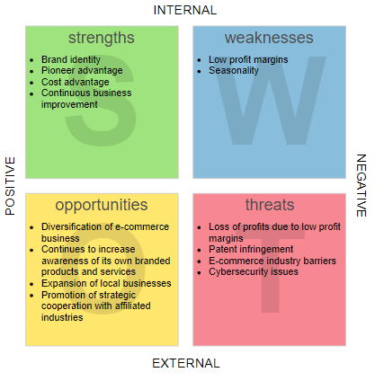
Source: https://warren2lynch.medium.com/from-swot-to-tows-analysis-55ac394064b7
USP
= unique selling proposition (USP), or a unique selling position, is a statement that succinctly outlines how your business, product, or service is different from that of your competition. It identifies what makes your business the better choice, and why your target clients should choose you over the competition.
Validate
= Validate, confirm, corroborate, substantiate, verify, and authenticate all mean to attest to the truth or validity of something.
Value promise/proposition
= A value proposition is a simple statement that summarizes why a customer would choose your product or service. A great value proposition may highlight what makes you different from competitors, but it should always focus on how customers define your value.

APPENDIX II

Task for student teams is:

Prepare a pitch according to the template. Work as a team to investigate and fill in all the things that are mentioned in the template. As a team you will give out a pitch according to the template to the Challenge expert at the online meeting Wednesday 30.3.2022 15:30-16:15 (EET)

Topics in the template
- Team intro (team members by name and country)
- The first slide presents the team and company name
- It pays to also have a short slogan/tag line, which presents what the company does and what it wants to influence
- Keep it short and memorable!

- The problem and current solution(what is our challenge, what is the current situation briefly)
  - What is the challenge you are solving?
  - Give a brief introduction
  - How is the problem currently being solved?
- YOUR Solution and and value promise
- Present your customers and how they use your product
- Images and videos are more effective than a lot of text
- Why is your product the best way to solve the problem?
- What is your value promise = why is your solution the best way of resolving the issue?
- If you have the opportunity to show a prototype, do it!

- The market (Define the market; who are our ideal customers; who are our competitors; our company´s strengths)
- Define the market.
- Who are your ideal customers?
- Who are your competitors?
- What are your company's strengths compared to competitors?

- Validation
  - How do you know that your company's solution is the best on the market?
  - How have you investigated the market's size and its interest in your product?

- The business model
  - How does your company make money?
  - What are your main sales and marketing channels through which you reach your customers?

- Future vision
  - What are the company´s opportunities in the long run?
  - How do you intend to achieve this?
  - If your company would get an investment, what would you use it for?
  - Salaries, permits, entering the market, sales and marketing, developing the product/service, tools, machines?

- Business idea in one sentence
  - Finally end your presentation by presenting your business idea in one (1) sentence
  - What is your business and to whom and how will you sell it?

