  - SCHEDULE
INSTRUCTIONS

  - Teachers material for the study module “Start-ups for sustainable environment created by youngsters”

changemaker

schedule 2021-2022
  - Teachers material for the study module “Start-ups for sustainable environment created by youngsters”
Current material is prepared for the teachers of upper secondary and vocational education students participating in Interreg Central Baltic project CB851 “ChangeMakers – Start-ups for sustainable environment created by youngsters”. Materials are compiled by the experts of University of Turku alongside with partners from Satakunta University of Applied Sciences, Tallinn technical University, Åland vocational school, Stockholm University and Riga technical University. The material aims to explain in more detail the lessons and team meetings of the study model 2021-2022. All study model materials are available at the Interreg Central Baltic ChangeMakers project’s e-learning platform:
https://sub.samk.fi/changemakers-eplatform/
Lesson structure: Each topic has a learning material (45 min) and a scheduled online meeting (45min) on Wednesdays 15:30- 16:15 (EEST &EET). Schools can choose to have lessons either before the student online meetings on Wednesdays 14:45-15:30 (EEST & EET) or earlier during the week.
NB! Prototyping lessons (1/2022) are an exception. Prototyping lessons are held as online workshops by the experts of Riga Technical University. Students are required to be online 19.1.2022 14:45-16:15 and 26.1.2022 14:45-16:15 (EET)
The schedule is provided as an appendix and also available at the project´s ePlatform: https://newsub.samk.fi/changemakers-eplatform/#teams

After the BootCamp (11/2021) all teams will be assigned a mentor that is present at all team meetings.
Students are required to use a laptop and a headset during online meetings.

LEARNING MATERIAL TIMELINE FOR 2021-2022

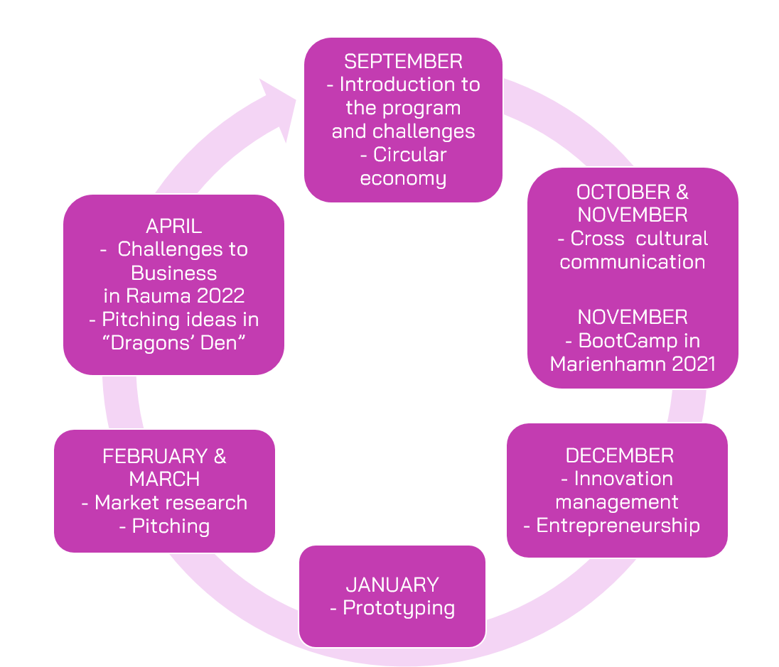

Contents

LEARNING MATERIAL TIMELINE FOR 2021-2022 3
SEPTEMBER 2021 6
1.9.2021 INTRODUCTION TO CHANGEMAKERS 6
Learning material: 6
13.9.2021 CIRCULAR ECONOMY 8
Learning material: 8
Online meeting 15.9.2021: 9
OCTOBER 2021 10
6.10.2021 CIRCULAR ECONOMY II 10
Learning material: 10
Online meeting 6.10.2021: 10
13.10.2021 CROSS CULTURAL COMMUNICATION I 11
Learning material: 11
Online meeting 13.10.2021: 11
CROSS CULTURAL COMMUNICATION II 12
Learning material: 12
NOVEMBER 2021 13
1.-3.11. 2O21 BOOTCAMP MARIEHAMN 13
Main themes for the event: 13
17.11.2021 INNOVATION MANAGEMENT 14
Learning material: 14
Online meeting 17.11.2021: 15
DECEMBER 2021 16
1.12.2021 ENTREPRENEURSHIP I 16
Online meeting 1.12.2021: 16
8.12.2021 17
ENTREPRENEURSHIP II 17
Online meeting 8.12.2021: 17
JANUARY 2022 18
19.1.2022 PROTOTYPING WORKSHOP I 18
Lesson description: 19
26.1.2022 PROTOTYPING WORKSHOP II 20
Lesson description: 20
FEBRUARY 2022 21
9.2.2022 MARKET RESEARCH I 21
Learning materials: 21
Online meeting 9.2.2022: 21
16.2.2022 MARKET RESEARCH II 22
Learning materials: 22
Online meeting 16.2.2022 22
MARCH 2022 24
9.3.2022 PITCHING I 24
Learning materials: 24
Online meeting 9.3.2022: 25
23.3.2O22 PITCHING II 25
Learning materials: 25
Online meeting 23.3.2022: 25
30.3.2022 PREPARING FOR THE DRAGON´S DEN 28
Learning materials: 28
Online meeting 30.3.2022: 28
APRIL 2022 29
PREPARING FOR THE DRAGOS DEN II 29
20.-22.4.2022 CHALLENGES TO BUSINESS BOOTCAMP 31
Main themes for the event: 31

SEPTEMBER 2021

1.9.2021 INTRODUCTION TO CHANGEMAKERS

Learning material:
During the first lesson the students are introduced to the project. Teachers will present the PowerPoint presentation “Introduction to ChangeMakers” available at the project´s ePlatform: https://newsub.samk.fi/changemakers-eplatform/
Teachers are advised to introduce the ePlatform to students and ask them to bookmark the ePlatform site to their own computer: https://newsub.samk.fi/changemakers-eplatform/
NB! No team meetings during the first lesson.

Tasks for the lesson:
- During the first lesson student pairs are formed. The pair will work together for the whole duration of the project. If the student number in a school is uneven, teachers are encouraged to seek out a student that is willing to work alone in the international team, and only if such a student cannot be found one group of 3 students can be formed.
- Students will create a Google account. An account can be created at: https://accounts.google.com/signup/v2/webcreateaccount?flowName=GlifWebSignIn&flowEntry=SignUp. The account and email will be the official account the students use to receive emails, access team meetings and hand in milestone assignments at the ePlatform.
- Teachers are advised to print and give to students the research and participation permits. Local country coordinators will distribute the permits in national languages. Guardians should sign the permits and the signed files should be scanned and sent to local country coordinators as soon as possible.
- Students and teachers prepare a 1 minute long video presenting the school and students. Schools have visual creativity on the video. Helpful main points: Name and country of the school, number of students participating, why the school is has chosen ChangeMakers. OPTIONAL IF YOU STILL HAVE TIME: how is circular economy and sustainable choices visible in the school?

Homework for students at the lesson 1.9.2021:
Students are encouraged to watch the 10 short videos (~1min. each) that open the main ideas behind circular economy and help further advancing the topic during the current course. The videos are to prepare the students for the next lessons “Circular economy I”. The recommended videos are part of a lesson 1 of Ellen MacArthur Foundation course and explain the different way of thinking about how our economy could work.
The video set covers following topics:
1. What is Circular economy: https://youtu.be/zCRKvDyyHmI.
2. Linear economy, take-make-dispose model of living and alternatives to it: https://www.youtube.com/watch?v=PU-hevOX0Qo;
3. Recycling: https://www.youtube.com/watch?v=RX14rA-tylo;
4. Using less: https://www.youtube.com/watch?v=mJFdW_Y4JDY;
5. Long-lasting: https://www.youtube.com/watch?v=a4dbNnIfcbc;
6. Efficiency factor: https://www.youtube.com/watch?v=u-qCn2tRp0w;
7. Green products: https://www.youtube.com/watch?v=LS7d2ZHEpQM;
8. Fewer people: https://www.youtube.com/watch?v=1fzj2ZLYLzQ;
9. How do other species live: https://www.youtube.com/watch?v=N6GNb0zTc2s;
10. The big picture and new perspective: https://youtu.be/KIp7Bjexf3Y

13.9.2021 CIRCULAR ECONOMY

Learning material:
During the lesson students are introduced to the topic of Circular Economy I. Teachers will present and teach learning materials (PowerPoint, videos):
- PowerPoint Circular Economy Lesson (slides 1-5) (10min)
- General discussion based on everyone’s personal experience and circular economy videos watched (previous homework). (15min)
- Natural cycles and waste (slides 7-13) (15 min)
- NB! The Teacher’s material also includes pages of concepts and definitions that are recommended to be explained.
Learning materials are available at the project´s ePlatform/ Circular economy: https://newsub.samk.fi/changemakers-eplatform/changemakers-eplatform-circular-economy/
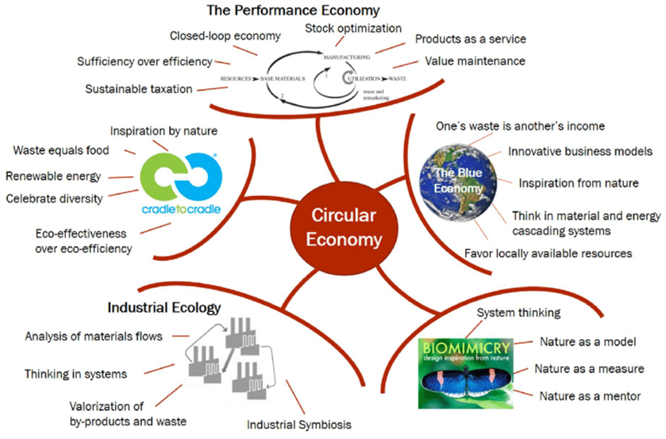

Online meeting 15.9.2021:
All schools will meet online Wednesday, September 15 at 15:30-16:15 (EEST) in Zoom: https://utu.zoom.us/my/katrimoisio the meeting is moderated by the project. The aim of the online meeting is to get to know other schools and introduce the students to 2 environmental challenges. Discussion and questions are encouraged. Topics discussed in the meeting:
- Presenting schools and 1 minute videos from all schools.
- Introducing 2 environmental Challenges:
  - How to reduce fabric waste in textile industry?
  - New innovations from disposable paper tableware
All challenges are available at the project´s ePlatform: https://newsub.samk.fi/changemakers-eplatform/challenges/

OCTOBER 2021

6.10.2021 CIRCULAR ECONOMY II

Learning material:
During the lessons students are introduced to the topic of Circular Economy II. Teachers will present and teach learning materials (PowerPoint, videos):
PowerPoint Circular Economy Lesson (14-22)
- Circular economy and sustainable design: Explain the circular economy idea further, using the slides and learning material provided (25min)
- Circular economy exercise: hand out different products for students to assess their present impact and assess how this could be improved towards circularity (20min)
Learning materials are prepared by the experts of Tallinn Technical University and available at the project´s ePlatform/ Circular economy: https://newsub.samk.fi/changemakers-eplatform/changemakers-eplatform-circular-economy/

Online meeting 6.10.2021:
All schools will meet online Wednesday, October 6 at 15:30-16:15 (EEST) in Zoom: https://utu.zoom.us/my/katrimoisio the meeting is moderated by the project. The aim of the meeting is to introduce 4 environmental challenges. Discussion and questions are encouraged. Topics discussed in the meeting:
- Introducing 4 environmental challenges
  - Rainwater as a resource in urban areas
  - Reduce inflow of marine litter from urban storm water systems
  - What to do with scrap tube from production?
  - How to reduce/reuse plastic waste from silage bales?

All challenges are available at the project´s ePlatform. https://newsub.samk.fi/changemakers-eplatform/challenges/

13.10.2021 CROSS CULTURAL COMMUNICATION I

Learning material:
During the lessons students are introduced to the topic of Cross Cultural communication I. Teachers will present and teach learning materials (PowerPoint, videos):
- Game playing activity to learn about miscommunication (15 min)
PowerPoint on cross-cultural communication (20 min)
- Group discussion to reflect on the topics and share the own experiences (10 min)
Learning materials are prepared by the experts of Stockholm University and available at the project´s ePlatform/ Cross border communication: https://newsub.samk.fi/changemakers-eplatform/cross-border-communication/

Online meeting 13.10.2021:
All schools will meet online Wednesday, October 13 at 15:30-16:15 (EEST) in Zoom: https://utu.zoom.us/my/katrimoisio the meeting is moderated by the project. The aim of the meeting is to introduce 4 environmental challenges. Discussion and questions are encouraged. Topics discussed in the meeting:
- Introducing 4 environmental challenges
  - How to make more sustainable choices?
  - How to reduce food waste?
  - Green hydrogen (H2) production and competitiveness in Latvia (Baltics)
  - Organic waste and composting in the cities – challenges into opportunities

All challenges are available at the project´s ePlatform. https://newsub.samk.fi/changemakers-eplatform/challenges/

CROSS CULTURAL COMMUNICATION II
(DURING WEEKS 42-43, PRIOR TO BOOTCAMP)

Learning material:
During the lesson students are introduced to the topic of Cross Cultural communication II. Teachers will present and teach learning materials.
- Role Play Activity to learn more about cross-cultural communication (30 min)
- Group discussion to reflect and draft the “principles of ChangeMakers community” (15 min)
Learning materials are prepared by the experts of Stockholm University and available at the project´s ePlatform/ Cross border communication: https://newsub.samk.fi/changemakers-eplatform/cross-border-communication/

Student task MILESTONE I Favorite Challenge:
Students vote in pars for their favourite challenges via Google Forms:
- Vote in national student pairs/trios
- Rank your favorite challenges on the scale of one to ten (1-10), one being the one you would most want to work on etc.
Link to the Google forms: https://forms.gle/wNDotrL6KzcFzCB18

International student teams will be formed based on the votes. Students are asked to vote in the Google forms in their national pairs.

DL for MILESTONE: 22.10.2021

NB! No team meetings during this lesson

NOVEMBER 2021

1.-3.11. 2O21 BOOTCAMP MARIEHAMN
The international event ChangeMakers BootCamp Mariehamn is held 1.-3.11.2021. The event is held either onsite, online or as a hybrid event depending on the Covid-19 situation. The official decision is made by the project in September 2021. Prior to the event a detailed program is provided. In case of travel local country coordinators will inform the schools and make travel arrangements.

Main themes for the event:
- International student teams are formed based on environmental challenge preference. 4-6 students in one team. Students meet their mentors and guidelines for online meetings are set.
- Workshops on ideation and cross cultural teamwork skills.
- Hands on activities on innovation, sustainability and building a team spirit
- Having fun!

Student task MILESTONE II team rules DL 3.11.2021
Students will decide, as newly established teams, their team rules during the event. Each team will submit their rules in the project´s ePlatform/ submit tasks: https://newsub.samk.fi/changemakers-eplatform/#submit

Students should name the file: Team X (number) ChangeMaker rules. Be sure to add all team member names in the file.

17.11.2021 INNOVATION MANAGEMENT

Learning material:
During the lesson students are introduced to the topic of Innovation Management. Teachers will present and teach learning materials (PowerPoint, videos):
- The lesson is divided in two parts (two separate materials prepared):
  - Theoretical material for teachers (45 min)
  - Practical material for students to use in team meeting online together with team mentor (45min). Mentors lead the online meeting.

Lesson content:
- Preparation: students to do some warmup tasks and gain intriguing innovation literature
- Introduction: general discussion based on everyone’s personal experience and the homework students were invited to complete (see previous chapter)
- Innovation management session: presentation with practical tasks
- Afterparty: additional creative thinking method, idea evaluation and development method exploration that could help in innovation management
Learning materials are prepared by the experts of Riga Technical University and available at the project´s ePlatform/ Innovation management: https://newsub.samk.fi/changemakers-eplatform/innovation-management/

Online meeting 17.11.2021:
Students meet online as a team for the first time! Each team will have a team meeting Wednesday, November 17, 15:30-16:15 (EET). Teams will log into their Google accounts and use the Google meet link provided by mentors to join the meeting. Each team can access their own site at the ePlatform to check once again the link and other instructions for the meeting. ePlatform/ teams: NB! The link will be provided in this file once the teams are formed at the BootCamp!

Mentors moderate the team meeting. The meeting aims at enhancing students’ innovative thinking and will consist of hands on activities.

DECEMBER 2021

1.12.2021 ENTREPRENEURSHIP I
During the lesson students are introduced to the topic of Entrepreneurship I Teachers will present and teach learning materials (PowerPoint, videos):
- Preparation: Discussion – what it means to be an entrepreneur? (10min)
- What Defines Entrepreneurship? What are the most important skills entrepreneurs need? (15min)
- One-pager (15min)
- Questions and answers (5min)
- Teachers explain the One-pager in national languages, students start working on the one-pager at their team meetings.
Learning materials are prepared by the experts of Satakunta University of Applied Sciences and available at the project´s ePlatform/ Entrepreneurship: https://newsub.samk.fi/changemakers-eplatform/entrepreneurship/

Online meeting 1.12.2021:
Students meet online as a team! Each team will have a team meeting Wednesday, December 1, 15:30-16:15 (EET). Teams will log into their Google accounts and use the Google meet link provided by mentors to join the meeting. Each team can access their own site at the ePlatform to check once again the link and other instructions for the meeting. ePlatform/ teams: NB! The link will be provided in this file once the teams are formed at the BootCamp!

Mentors moderate the meeting. Students will start working on the OnePager, as a team. During the meeting the teams discuss questions that they have for the challenge expert about their OnePager. The mentor will send the questions to the Challenge expert.

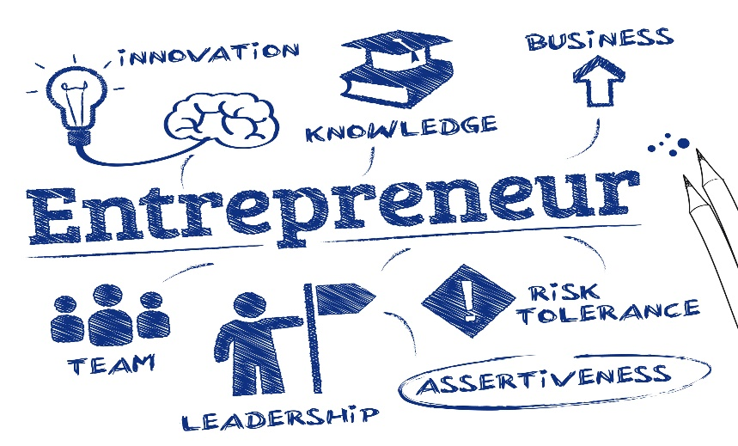

8.12.2021

ENTREPRENEURSHIP II

During the lesson students are introduced to the topic of Entrepreneurship II Teachers will present and teach learning materials (PowerPoint, videos):
- Lessons learned from the last time (5min)
- What is The Strategy and why do you need it as entrepreneur? (15min)
- Entrepreneurship and circular economy business models (15min)
- Questions and answers (10min)
Learning materials are prepared by the experts of Satakunta University of Applied Sciences and available at the project´s ePlatform/ Entrepreneurship: https://newsub.samk.fi/changemakers-eplatform/entrepreneurship/

Online meeting 8.12.2021:
Students meet online as a team! Each team will have a meeting on Wednesday, December 8, 15:30-16:15 (EET). Teams will log into their Google accounts and use the Google meet link provided by mentors to join the meeting. Each team can access their own site at the ePlatform to check once again the link and other instructions for the meeting. ePlatform/ teams: NB! The link will be provided in this file once the teams are formed at the BootCamp!
The challenge expert joins the students’ team meeting. Challenge expert is a representative from the company that has provided the challenge or a project worker with background knowledge of the Challenge. At the team meeting the expert will provide feedback on the students One-Pager and based on the feedback students will finish the One-Pager.

Student task MILESTONE III One-Pager
Each team will submit their milestone One-Pager in the project´s ePlatform/ submit tasks: https://newsub.samk.fi/changemakers-eplatform/#submit

DL for MILESTONE: DL 11.12.2021
Students should name the file: Team X (number) ChangeMaker One-Pager. Be sure to add all team member names in the file.

JANUARY 2022

Schools are advised to continue and further develop student teams´ prototypes during January and February. Further developing depends on the resources and time within each school as well as the on the idea of each student team.
An example: Drawing with Tinkercad or SketchUp, making a product based on prototyping, creating a website for e-commerce, creating an app for service etc.

19.1.2022 PROTOTYPING WORKSHOP I
During the workshop students will learn to turn their ideas into prototypes. The workshop is held online via Zoom 14:45-16:15 (EET) and moderated by the experts of Riga Technical University. Zoom link to the meeting: NB! Zoom link updated in this file December 2021!
Learning materials are available at the project´s ePlatform/Prototyping: https://newsub.samk.fi/changemakers-eplatform/prototyping/

Lesson description:
Each team will make their ideas prototype as a physical and tangible thing or do it online. The process helps to define the idea and the process how it works. After the workshop each team validates the idea with potential customers and updates the prototype.
NB! No additional team meetings 19.1.2022 as the workshop lasts 90min.

Students task for the next workshop:
- Improve the prototype and validate it with potential customers (peers, parents, teachers, mentor etc.) individually or in a team.
- Have a team meeting and talk about validation results and what needs to be improved. NB! Students schedule this team meeting time amongst themselves and with each mentor. The meeting will take place outside of school hours.
- Prepare a 5 min presentation in a team:
        - What is the problem you are solving?
        - How did you get to the solution of the problem?
        - What is the solution?
        - What kind of validation and with whom did you have?

26.1.2022 PROTOTYPING WORKSHOP II

During the workshop student teams will receive feedback of their prototype from the challenge expert and present their updated prototype. . The workshop is held online via Zoom 14:45-16:15 (EET) and moderated by the experts of Riga Technical University. Zoom link to the meeting: Zoom link will be updated in this file January 2022.
Learning materials are available at the project´s ePlatform/Prototyping: https://newsub.samk.fi/changemakers-eplatform/prototyping/

Lesson description:
Lesson is held together with online team meeting and lead by RTU together for 90 min in a row. Each challenge experts are invited to team meeting time online. Each team presents their updated prototype after validation with potential customers. Their challenge experts and experts from other fields give feedback about the prototype and the idea as a whole. Afterwards all the teams for the same challenge are put together in a breakout room with challenge expert for Q&A session.
NB! No additional team meetings 26.1.2022 as the workshop lasts 90min.

Student task MILESTONE IV Prototype:
Each team will submit their milestone Prototype in the project´s ePlatform/ submit tasks: https://newsub.samk.fi/changemakers-eplatform/#submit

DL for MILESTONE: 4.2.2022
Students should name the file: Team X (number) ChangeMaker Prototype. Be sure to add all team member names in the file.

FEBRUARY 2022

9.2.2022 MARKET RESEARCH I

During the lesson students are introduced to the topic of Market research I. Teachers will present and teach learning materials (PowerPoint, videos):

Learning materials:
- Preparation: interactive game on the importance of market research (10min)
- Market research (what is market research) (10min)
- Why do you need market research? (10min)
- Types of market research (5min)
- How to do market research for identifying your buyer persona? (10min)

After the lesson the students have gained Instructions & template for the questionnaire. After this they will then work in teams to come up with the questions/implementation plan.
Learning materials are prepared by the experts of Satakunta University of Applied Sciences and available at the project´s ePlatform/Market research: https://newsub.samk.fi/changemakers-eplatform/market-research/

Online meeting 9.2.2022:
Students meet online as a team! Each team will have a meeting on Wednesday, February 9, 15:30-16:15 (EET). Teams will log into their Google accounts and use the Google meet link provided by mentors to join the meeting. Each team can access their own site at the ePlatform to check once again the link and other instructions for the meeting. ePlatform/ teams: NB! The link will be provided in this file once the teams are formed at the BootCamp!

The meetings is moderated by mentors. Each team will come up with questions for their market research (example questions provided in the learning material).
Student task: Each student will interview at least one (1) person and conduct mini market research. At the next meeting answers are compiled and the product/service/solution of each team is updated based on the answers.

16.2.2022 MARKET RESEARCH II
During the lesson students are introduced to the topic of Market research II. Teachers will present and teach learning materials (PowerPoint, videos):

Learning materials:
- Preparations: Lessons learnt from the previous lesson (10min)
- Who are your competitors? (5min)
- Tips to summarize your findings (5min)
- Digital Marketing (5min)
- Branding and Green branding (10min)
- Marketing plan (instructions & template) and Discussion (10min)

Learning materials are prepared by the experts of Satakunta University of Applied Sciences and available at the project´s ePlatform/ Market research: https://newsub.samk.fi/changemakers-eplatform/market-research/

Online meeting 16.2.2022
Students meet online as a team! Each team will have a meeting on Wednesday, February 16, 15:30-16:15 (EET). Teams will log into their Google accounts and use the Google meet link provided by mentors to join the meeting. Each team can access their own site at the ePlatform to check once again the link and other instructions for the meeting. ePlatform/ teams: NB! The link will be provided in this file once the teams are formed at the BootCamp!

The meeting is moderated by mentors. Student teams compile their answers that they received from their mini market research and update their product/service/app based on the results. Mentors will introduce the Lean Business plan to students.

Student task MILESTONE V Marketing plan:
Each team will submit their milestone Prototype in the project´s ePlatform/ submit tasks: https://newsub.samk.fi/changemakers-eplatform/#submit

DL for MILESTONE: 18.2.2022
Students should name the file: Team X (number) ChangeMaker Marketing plan. Be sure to add all team member names in the file.

MARCH 2022

9.3.2022 PITCHING I
During the lesson students are introduced to the topic of Pitching I. Teachers will present and teach learning materials (PowerPoint, videos):

Learning materials:
- Learning material: Power point Pitching part One
- Lesson description:
Preparation – Discuss pitching with your students and watch an introductory video. (10 min)
Pitching (20 min)
What is a pitch, different types of pitching.
Student tasks 1- 2.
- The structure of a well-prepared pitch 1. (15 min)

Learning materials are prepared by the experts of Åland´s vocational school and available at the project´s ePlatform/ Pitching: https://newsub.samk.fi/changemakers-eplatform/pitching/

Online meeting 9.3.2022:
Students meet online as a team! Each team will have a meeting on Wednesday, March 9, 15:30-16:15 (EET). Teams will log into their Google accounts and use the Google meet link provided by mentors to join the meeting. Each team can access their own site at the ePlatform to check once again the link and other instructions for the meeting. ePlatform/ teams: NB! The link will be provided in this file once the teams are formed at the BootCamp!

The meeting is moderated by mentors. Students will start to prepare for their pitch based on the pitching template.

23.3.2O22 PITCHING II
During the lesson students are introduced to the topic of Pitching II. Teachers will present and teach learning materials (PowerPoint, videos):

Learning materials:
- Learning material: Power point Pitching part Two
- Lesson description:
- The structure of a well-prepared pitch 2. (15 min)
- Student task 3. (30 min)

Learning materials are prepared by the experts of Åland´s vocational school and available at the project´s ePlatform/ Pitching: https://newsub.samk.fi/changemakers-eplatform/pitching/

Online meeting 23.3.2022:
Students meet online as a team! Each team will have a meeting on Wednesday, March 23, 15:30-16:15 (EET). Teams will log into their Google accounts and use the Google meet link provided by mentors to join the meeting. Each team can access their own site at the ePlatform to check once again the link and other instructions for the meeting. ePlatform/ teams: NB! The link will be provided in this file once the teams are formed at the BootCamp!
The meeting is moderated by mentors. Student teams will continue preparing their pitches and finish the pitching template

30.3.2022 PREPARING FOR THE DRAGON´S DEN

During the lesson students are introduced to the topic of Preparing for the Dragon´s Den. Teachers will present and teach learning materials (PowerPoint, videos):

Learning materials:

- Public speaking exercises and information regarding the Dragon´s Den event
- Video making instructions and good tips.

Learning materials are prepared by the experts of University of Turku and available at the project´s ePlatform/ NB! Link will be added in this file early 2022.

Online meeting 30.3.2022:
Students meet online as a team! Each team will have a meeting on Wednesday, March 30, 15:30-16:15 (EET). Teams will log into their Google accounts and use the Google meet link provided by mentors to join the meeting. Each team can access their own site at the ePlatform to check once again the link and other instructions for the meeting. ePlatform/ teams: NB! The link will be provided in this file once the teams are formed at the BootCamp!

The meeting is moderated by mentors. Challenge experts join the team meetings, and give feedback to student´s pitches.

Student task MILESTONE VI Lean business plan
Each team will submit their milestone Prototype in the project´s ePlatform/ submit tasks: https://newsub.samk.fi/changemakers-eplatform/#submit

DL for MILESTONE: 1.3.2022
Students should name the file: Team X (number) ChangeMaker Lean business plan. Be sure to add all team member names in the file.

APRIL 2022

PREPARING FOR THE DRAGOS DEN II
(During week 15 NB! The lesson is voluntary)
During this voluntary lesson teachers are advised to help the students to prepare for the Dragon´s Den. Public speaking exercises can be continued and teachers can help the students to finalize their pitch and answer any questions they might have. The aim for the lesson is to make sure that all teams and students are prepared for the Dragon´s Den.

NB! No set team meetings! Teams can have voluntary team meetings if necessary. The voluntary team meetings will happen outside of school hours and are set individually in each team.

Student task MILESTONE VII Pitch:
Each team will submit their milestone Prototype in the project´s ePlatform/ submit tasks: https://newsub.samk.fi/changemakers-eplatform/#submit

DL for MILESTONE: 14.3.2022
Students should name the file: Team X (number) ChangeMaker Pitch. Be sure to add all team member names in the file.

20.-22.4.2022 CHALLENGES TO BUSINESS BOOTCAMP
The international event ChangeMakers Challenges to Business BootCamp Rauma is held 20.-22.4.2022. The event is held either onsite, online or as a hybrid event depending on the Covid-19 situation. Prior to the event a detailed program is provided. In case of travel local country coordinators will inform the schools and make travel arrangements.

Main themes for the event:

- Dragon´s Den; student teams present their ready business ideas to panel of jury members. Best teams are rewarded!
- Diplomas for all students.
- Having fun!

